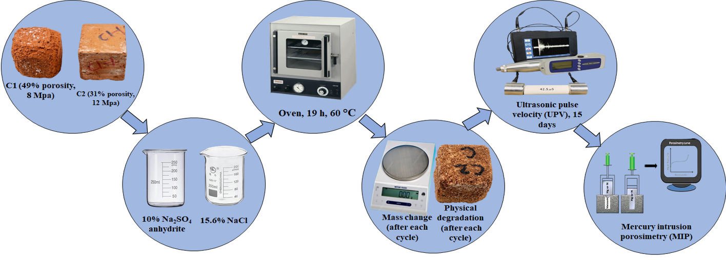

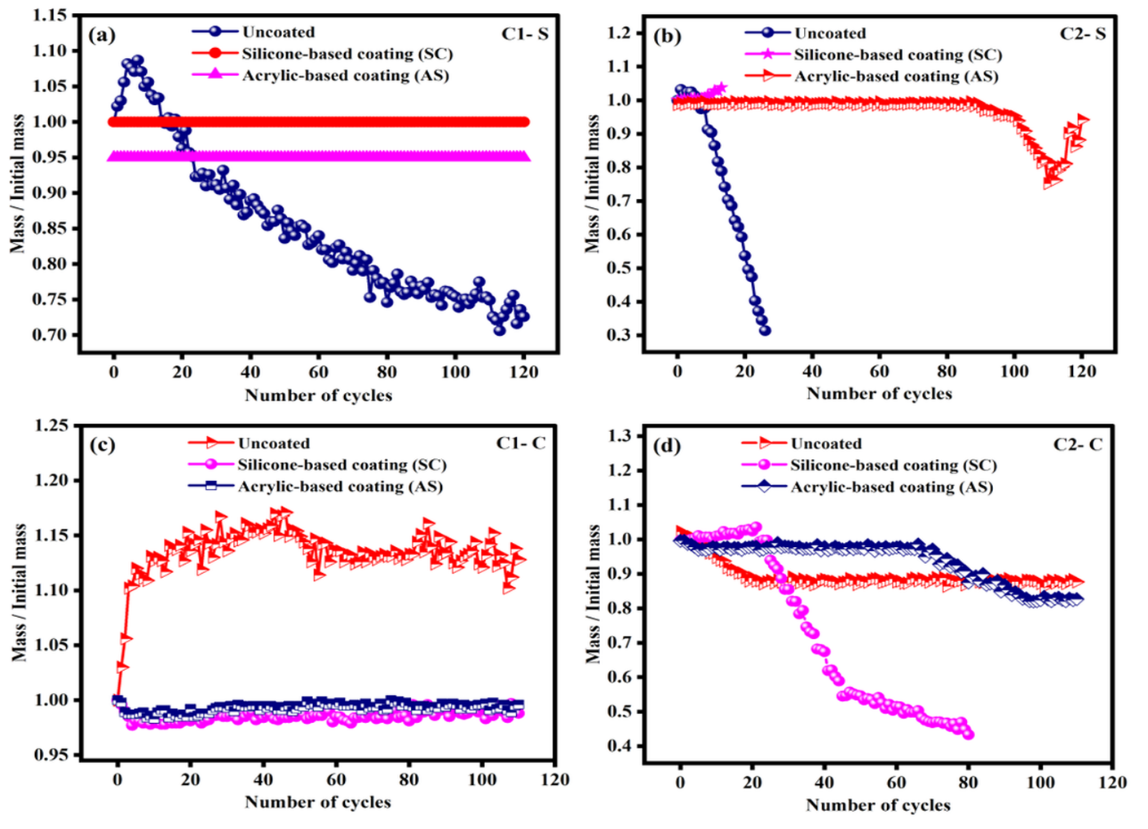
Scheme: A graph shows two types of commercial bricks, Na₂SO₄ and NaCl.

Fig. 1. Mass fluctuations during accelerated salt weathering cycles: (a) sulfate-exposed C1, (b) sulfate-exposed C2, (c) chloride-exposed C1, and (d) chloride-exposed C2 specimens.
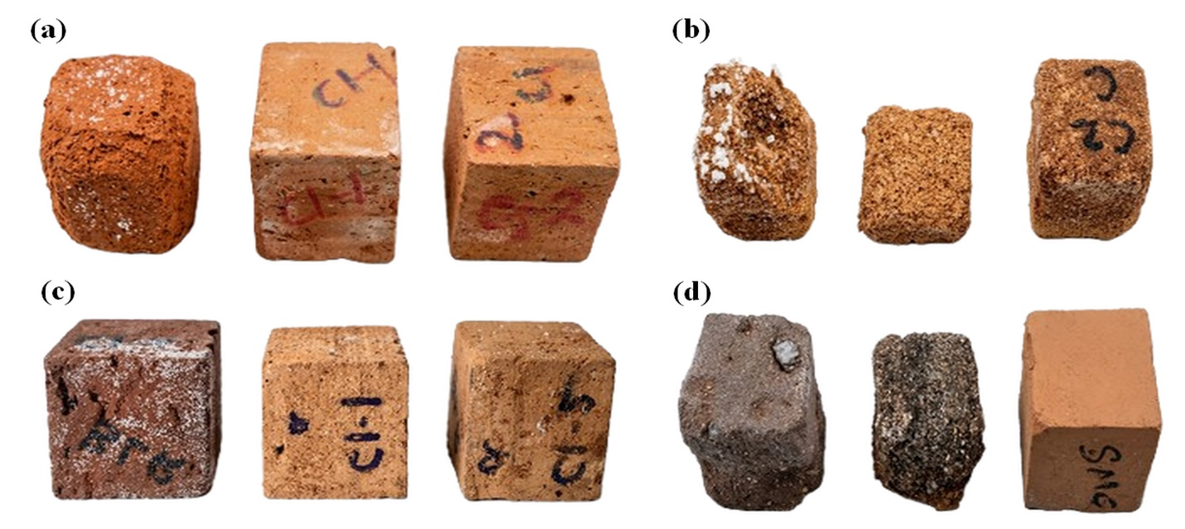
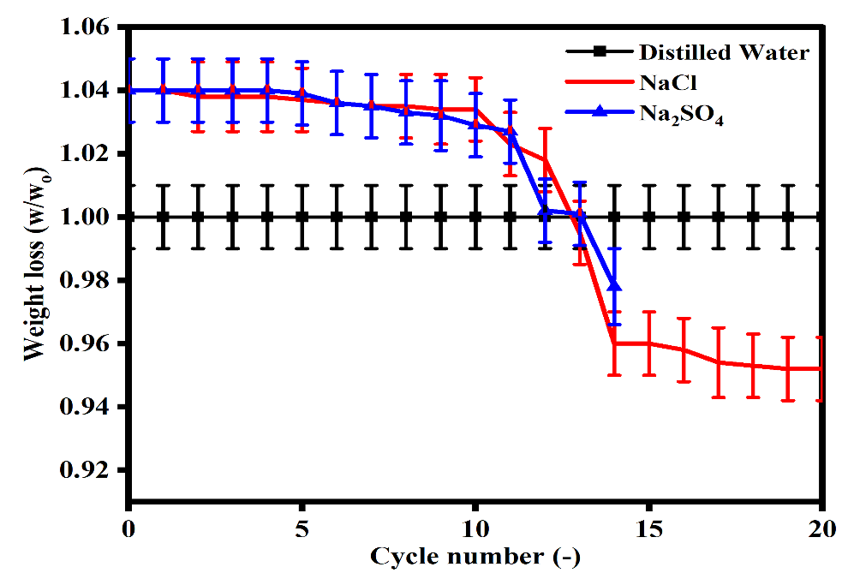
Fig. 2. (a) Physical degradation of C1, C1-SC, and C1-AS specimens following 30 accelerated weathering cycles, (b) Comparative damage state of untreated and treated C2 brick variants after 30 rounds of weathering, (c) Visible weathering and material integrity of the various C1 brick configurations following 90th test cycles, and (d) Visible weathering and material integrity of the various C2 brick configurations following 90th test cycles.

Fig. 3. Weight loss profiles of fired-clay brick samples subjected to 20 wet-dry weathering cycles during immersion in DI water, 10% NaCl, and saturated Na₂SO₄ solutions.
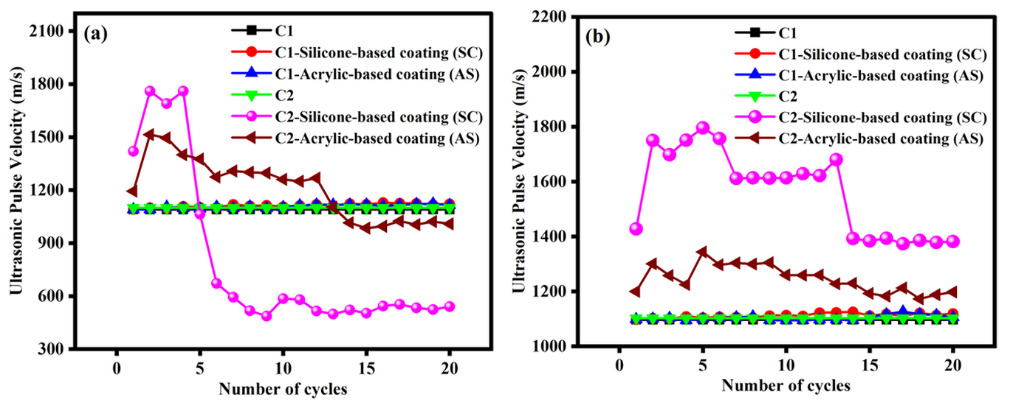
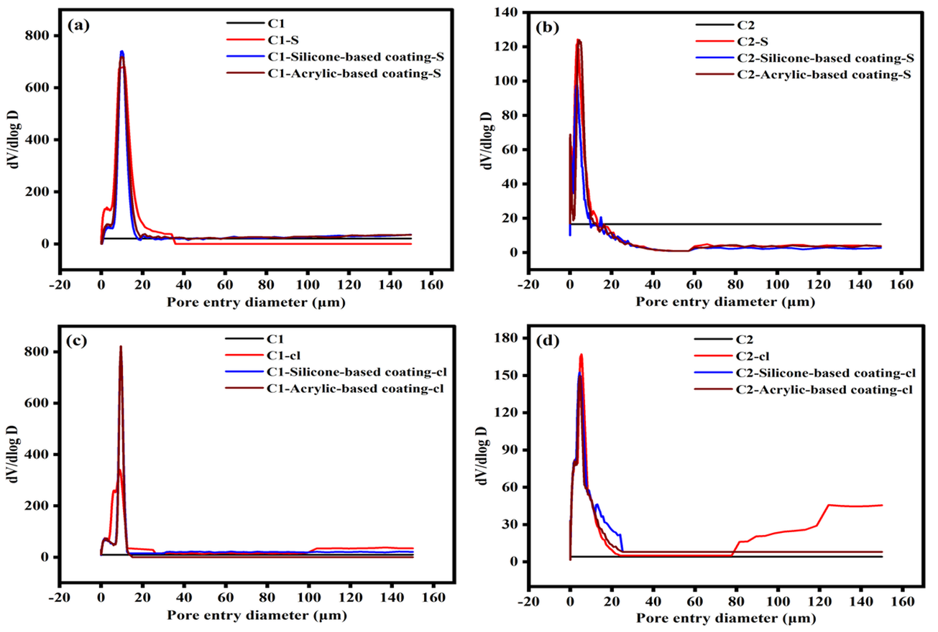
Fig. 4. UPV variations across successive weathering cycles for samples exposed to: (a) sulfate salt and (b) chloride salt solutions.

Fig. 5. Differential mercury intrusion curves comparing unweathered baseline samples with coated specimens subjected to accelerated NaCl weathering: (a) C1 substrate, (b) C2 substrate, (c) C1 brick profiles, and (d) C2 brick profiles.Description

